

INFORME JULIO 2020

ADMINISTRACION

RESUMEN MENSUAL
CONTENIDO.

- Finanzas

A.- ingresos
B.- egresos
C.- morosidad
2. Operaciones
A.- mantenimientos
B.- trabajos
- Administrativas

A.- informativas
B.- otras actividades
C.- recomendaciones

- Finanzas
Resumen financiero Julio 2020

INGRESO ESTIMADO ORDINARIO B/. 30,382.03
INGRESO REAL ORDINARIO B/. 31,692.80
EGRESOS MES DE JULIO 2020 B/. 30,751.69
SALDO MES DE JULIO 2020 B/. 941.11
ANTICIPOS TOTALES 2020 B/. 8326.04
ANTICIPOS PRORRATEADOS B/. 1665.20
MOROSIDAD CUOTA MANT B/. 14098.03
CUOTA EXTRA RECAUDADA JULIO B/. 4289.21
TOTAL DE LA CUOTA EXTRA RECAUDADA B/. 31949.84
CANCELACION A TRABAJOS C.EXTRA B/ . 28800.00
SALDO DE CUOTAS EXTRA 2020 B/. 3,149.84
SALDO DE CUOTAS DE MANTEN B/. 15,456.54
SALDO CTA AHORRO AL 31/07 B/. 20,447.40
SALDO CTA CORRIENTE AL 31/07 B/. 15,456.54

DETALLES DE INGRESOS
Date | Line Description | Debit Amnt | Credit Amnt | Customer ID
7/6/20 | COMISION VENDING MACHINE |  | 7.35 | COMISION VENDING MAC
7/6/20 | COMISION VENDING MACHINE | 7.35 |  | COMISION VENDING MAC
7/31/20 | INTERESES CARGADOS MES DE JULIO 2020 |  | 19.82 | INTERES CTA AHORRO
7/31/20 | INTERES CTA AHORRO | 19.82 |  | INTERES CTA AHORRO
7/11/20 | Invoice: T1-10A-0720 |  | 235.15 | T1-10A
7/11/20 | Invoice: T1-10A-0820 |  | 9.85 | T1-10A
7/11/20 | FLOR GUEVARA / ALI GUEVARA | 245.00 |  | T1-10A
7/11/20 | Invoice: T1-10A-CEXTRA20 |  | 100.00 | T1-10A
7/11/20 | FLOR GUEVARA / ALI GUEVARA | 100.00 |  | T1-10A
7/2/20 | Invoice: T1-10B-0620 |  | 245.43 | T1-10B
7/2/20 | DIPECO, S.A. | 245.43 |  | T1-10B
7/6/20 | Invoice: T1-10B-0720 |  | 245.43 | T1-10B
7/6/20 | DIPECO, S.A. | 245.43 |  | T1-10B
7/1/20 | Invoice: T1-10D-0120 |  | 65.19 | T1-10D
7/1/20 | Invoice: T1-10D-0220 |  | 107.71 | T1-10D
7/1/20 | LUIS SANCHEZ/LEONILDA SANCHEZ | 172.90 |  | T1-10D
7/7/20 | Invoice: T1-11A-0720 |  | 243.31 | T1-11A
7/7/20 | Invoice: T1-11A-0820 |  | 0.40 | T1-11A
7/7/20 | MARIANO LOPEZ | 243.71 |  | T1-11A
7/7/20 | Invoice: T1-11A-CEXTRA20 |  | 94.97 | T1-11A
7/7/20 | MARIANO LOPEZ | 94.97 |  | T1-11A
7/27/20 | Invoice: T1-11A-0820 |  | 243.21 | T1-11A
7/27/20 | Invoice: T1-11A-0920 |  | 0.50 | T1-11A
7/27/20 | MARIANO LOPEZ | 243.71 |  | T1-11A
7/27/20 | Invoice: T1-11A-CEXTRA20 |  | 94.97 | T1-11A
7/27/20 | MARIANO LOPEZ | 94.97 |  | T1-11A
7/7/20 | Invoice: T1-11B-0720 |  | 233.44 | T1-11B
7/7/20 | Invoice: T1-11B-0820 |  | 16.56 | T1-11B
7/7/20 | JESUS RAVELO PEREZ | 250.00 |  | T1-11B
7/4/20 | Invoice: T1-11C-CEXTRA20 |  | 75.00 | T1-11C
7/4/20 | AVELINA BARREIRO | 75.00 |  | T1-11C
7/7/20 | Invoice: T1-11D-CEXTRA20 |  | 66.83 | T1-11D
7/7/20 | Invoice: T1-11D-0720 |  | 183.30 | T1-11D
7/7/20 | INVERSIONES POCRES. S.A | 250.13 |  | T1-11D
7/1/20 | Invoice: T1-12A-0720 |  | 243.61 | T1-12A
7/1/20 | ESTEBAN ORTIZ | 243.61 |  | T1-12A
7/1/20 | Invoice: T1-12D-0720 |  | 183.30 | T1-12D
7/1/20 | SANCHINARRO S.A | 183.30 |  | T1-12D
7/7/20 | Invoice: T1-13A-0720 |  | 243.61 | T1-13A
7/7/20 | ALFREDO GONZALES Y BETTY CONTRERAS | 243.61 |  | T1-13A
7/2/20 | Invoice: T1-13C-0720 |  | 195.87 | T1-13C
7/2/20 | INVERSIONES CUBITRECE, S.A | 195.87 |  | T1-13C
7/2/20 | Invoice: T1-13C-C.EXTRA |  | 75.00 | T1-13C
7/2/20 | INVERSIONES CUBITRECE, S.A | 75.00 |  | T1-13C
7/6/20 | Invoice: T1-13D-CEXTRA21 |  | 94.97 | T1-14A
7/6/20 | KONSTANTIN VOLKOV | 94.97 |  | T1-14A
7/6/20 | Invoice: T1-14A-0720 |  | 240.77 | T1-14A
7/6/20 | Invoice: T1-14A-0820 |  | 3.23 | T1-14A
7/6/20 | KONSTANTIN VOLKOV | 244.00 |  | T1-14A
7/1/20 | Invoice: T1-14C-CEXTRA20 |  | 75.00 | T1-14C
7/1/20 | LUIS FERNANDO DEL RIO | 75.00 |  | T1-14C
7/4/20 | Invoice: T1-14C-0720 |  | 195.87 | T1-14C
7/4/20 | LUIS FERNANDO DEL RIO | 195.87 |  | T1-14C
7/1/20 | Invoice: T1-14D-0620 |  | 166.44 | T1-14D
7/1/20 | Invoice: T1-14D-0720 |  | 19.56 | T1-14D
7/1/20 | ANGEL RICARDO TALAVERA | 186.00 |  | T1-14D
7/4/20 | Invoice: T1-15A-CEXTRA20 |  | 94.97 | T1-15A
7/4/20 | K-LAB PANAMA | 94.97 |  | T1-15A
7/16/20 | Invoice: T1-15B-0720 |  | 242.09 | T1-15B
7/16/20 | Invoice: T1-15B-0820 |  | 3.91 | T1-15B
7/16/20 | CARLOS JOSE ZAVARCE | 246.00 |  | T1-15B
7/2/20 | Invoice: T1-15C-0720 |  | 195.87 | T1-15C
7/2/20 | ROSARIO DANIEL PENNISI | 195.87 |  | T1-15C
7/2/20 | Invoice: T1-15C-CEXTRA20 |  | 75.00 | T1-15C
7/2/20 | ROSARIO DANIEL PENNISI | 75.00 |  | T1-15C
7/7/20 | Invoice: T1-15D-0720 |  | 183.30 | T1-15D
7/7/20 | DAVID NG CHONG | 183.30 |  | T1-15D
7/7/20 | Invoice: T1-16B-CEXTRA20 |  | 134.57 | T1-16B
7/7/20 | Invoice: T1-16B-0720 |  | 245.43 | T1-16B
7/7/20 | ANDREW MICHEL GARRET | 380.00 |  | T1-16B
7/1/20 | Invoice: T1-16C-CEXTRA20 |  | 150.00 | T1-16C
7/1/20 | Invoice: T1-16C-0620 |  | 195.87 | T1-16C
7/1/20 | Invoice: T1-16C-0720 |  | 195.87 | T1-16C
7/1/20 | DAMIEN JOEL FERNAND RINJONNEAU | 541.74 |  | T1-16C
7/16/20 | Invoice: T1-16D-0620 |  | 36.75 | T1-16D
7/16/20 | Invoice: T1-16D-0720 |  | 146.55 | T1-16D
7/16/20 | ANGEL SERAFIN MASPARROTE | 183.30 |  | T1-16D
7/7/20 | Invoice: T1-17A-0720 |  | 243.61 | T1-17A
7/7/20 | FREDY CHERIGO | 243.61 |  | T1-17A
7/16/20 | Invoice: T1-17A-CEXTRA20 |  | 94.97 | T1-17A
7/16/20 | FREDY CHERIGO | 94.97 |  | T1-17A
7/23/20 | Invoice: TOKEN |  | 20.00 | T1-17A
7/23/20 | FREDY CHERIGO | 20.00 |  | T1-17A
7/1/20 | Invoice: T1-17B-0720 |  | 243.72 | T1-17B
7/1/20 | Invoice: T1-17B-0820 |  | 2.28 | T1-17B
7/1/20 | ALBANO ALBERTO AGUILAR | 246.00 |  | T1-17B
7/20/20 | Invoice: T1-17B-CEXTRA20 |  | 100.00 | T1-17B
7/20/20 | ALBANO ALBERTO AGUILAR | 100.00 |  | T1-17B
7/7/20 | Invoice: T1-17C-0620 |  | 10.40 | T1-17C
7/7/20 | Invoice: T1-17C-0720 |  | 185.47 | T1-17C
7/7/20 | CORPORACION G.F.G, S.A | 195.87 |  | T1-17C
7/6/20 | Invoice: T1-17D-CEXTRA20 |  | 66.83 | T1-17D
7/6/20 | VICTOR MURILLO | 66.83 |  | T1-17D
7/6/20 | Invoice: T1-17D-0720 |  | 183.30 | T1-17D
7/6/20 | VICTOR MURILLO | 183.30 |  | T1-17D
7/1/20 | Invoice: T1-19A-0720 |  | 243.61 | T1-18A
7/1/20 | MARISSA DEL CARMEN GONZALEZ RUIZ | 243.61 |  | T1-18A
7/11/20 | Invoice: T1-19B-0720 |  | 242.75 | T1-18B
7/11/20 | Invoice: T1-19B-0820 |  | 2.68 | T1-18B
7/11/20 | RATNA MOHAN | 245.43 |  | T1-18B
7/11/20 | Invoice: T1-18A-CEXTRA21 |  | 94.97 | T1-18B
7/11/20 | RATNA MOHAN | 94.97 |  | T1-18B
7/16/20 | Invoice: T1-19D-0720 |  | 183.30 | T1-18D
7/16/20 | BRUNO VITALE | 183.30 |  | T1-18D
7/16/20 | Invoice: T1-19A-0520 |  | 150.00 | T1-19A
7/16/20 | DANIEL DURAN | 150.00 |  | T1-19A
7/16/20 | Invoice: T1-19A-0520 |  | 93.61 | T1-19A
7/16/20 | Invoice: T1-19A-0620 |  | 6.39 | T1-19A
7/16/20 | DANIEL DURAN | 100.00 |  | T1-19A
7/30/20 | Invoice: T1-19C-0620 |  | 35.26 | T1-19C
7/30/20 | Invoice: T1-19C-0720 |  | 147.74 | T1-19C
7/30/20 | PARKSIDE CONDO S.A | 183.00 |  | T1-19C
7/14/20 | Invoice: T1-19D-CEXTRA20 |  | 66.83 | T1-19D
7/14/20 | Invoice: T1-19D-0720 |  | 181.33 | T1-19D
7/14/20 | Invoice: T1-19D-0820 |  | 1.84 | T1-19D
7/14/20 | JAMES NICHOLAS AMSAY | 250.00 |  | T1-19D
7/1/20 | Invoice: T1-20A-0720 |  | 478.88 | T1-20A
7/1/20 | FUNDACION DOUFOURTCHANG | 478.88 |  | T1-20A
7/4/20 | Invoice: T1-4A-0720 |  | 239.81 | T1-4A
7/4/20 | Invoice: T1-4A-0820 |  | 3.80 | T1-4A
7/4/20 | RODRIGO TEXEIRA ESQUIVEL | 243.61 |  | T1-4A
7/6/20 | Invoice: T1-4B-0720 |  | 245.43 | T1-4B
7/6/20 | ROBERTO TEXEIRA ESQUIVEL | 245.43 |  | T1-4B
7/16/20 | Invoice: T1-4C-0820 |  | 195.87 | T1-4C
7/16/20 | MARLYN QUIROZ MONTERREY | 195.87 |  | T1-4C
7/7/20 | Invoice: T1-4D-0720 |  | 183.30 | T1-4D
7/7/20 | ANA JANETH GONZALEZ MONROY | 183.30 |  | T1-4D
7/7/20 | Invoice: T1-5A-0720 |  | 243.61 | T1-5A
7/7/20 | ROBERTO TEXEIRA ESQUIVEL | 243.61 |  | T1-5A
7/6/20 | Invoice: T1-5B-0720 |  | 245.43 | T1-5B
7/6/20 | ILKA ESQUIVEL | 245.43 |  | T1-5B
7/1/20 | Invoice: T1-5C-CEXTRA20 |  | 600.47 | T1-5C
7/1/20 | DIDO CHONG | 600.47 |  | T1-5C
7/1/20 | Invoice: T1-5C-0720 |  | 195.87 | T1-5C
7/1/20 | DIDO CHONG | 195.87 |  | T1-5C
7/31/20 | Invoice: T1-5C-CEXTRA20 |  | 200.00 | T1-5C
7/31/20 | DIDO CHONG | 200.00 |  | T1-5C
7/31/20 | Invoice: T1-5C-0820 |  | 195.87 | T1-5C
7/31/20 | DIDO CHONG | 195.87 |  | T1-5C
7/7/20 | Invoice: T1-5D-0720 |  | 83.30 | T1-5D
7/7/20 | INMOBILIARIA FRANCOLIN S.A | 83.30 |  | T1-5D
7/23/20 | Invoice: T1-5D-0720 |  | 100.00 | T1-5D
7/23/20 | INMOBILIARIA FRANCOLIN S.A | 100.00 |  | T1-5D
7/27/20 | Invoice: T1-5D-CEXTRA20 |  | 66.83 | T1-5D
7/27/20 | INMOBILIARIA FRANCOLIN S.A | 66.83 |  | T1-5D
7/30/20 | Invoice: T1-6A-CEXTRA20 |  | 95.00 | T1-6A
7/30/20 | VASUDEV KHEMLANI | 95.00 |  | T1-6A
7/30/20 | Invoice: T1-6A-0820 |  | 243.61 | T1-6A
7/30/20 | VASUDEV KHEMLANI | 243.61 |  | T1-6A
7/29/20 | Invoice: T1-6C-0320 |  | 195.87 | T1-6C
7/29/20 | Invoice: T1-6C-0420 |  | 195.87 | T1-6C
7/29/20 | Invoice: T1-6C-0520 |  | 195.87 | T1-6C
7/29/20 | Invoice: T1-6C-0620 |  | 195.87 | T1-6C
7/29/20 | Invoice: T1-6C-0720 |  | 195.87 | T1-6C
7/29/20 | JIN HAO CHEN | 979.35 |  | T1-6C
7/1/20 | Invoice: T1-6D-0720 |  | 183.30 | T1-6D
7/1/20 | CLAUDIO SERRANO | 183.30 |  | T1-6D
7/2/20 | Invoice: T1-6D-CEXTRA20 |  | 60.59 | T1-6D
7/2/20 | CLAUDIO SERRANO | 60.59 |  | T1-6D
7/7/20 | Invoice: T1-7A-0620 |  | 243.61 | T1-7A
7/7/20 | IÑAKI GARCIA Y MANUELA CAMACHO | 243.61 |  | T1-7A
7/1/20 | Invoice: T1-7B-0620 |  | 245.43 | T1-7B
7/1/20 | TANIA MORALES | 245.43 |  | T1-7B
7/1/20 | Invoice: T1-7B-CEXTRA20 |  | 94.97 | T1-7B
7/1/20 | TANIA MORALES | 94.97 |  | T1-7B
7/30/20 | Invoice: T1-7B-0720 |  | 245.43 | T1-7B
7/30/20 | TANIA MORALES | 245.43 |  | T1-7B
7/11/20 | Invoice: T1-7C-1119 |  | 200.80 | T1-7C
7/11/20 | Invoice: T1-7C-1219 |  | 215.45 | T1-7C
7/11/20 | Invoice: T1-7C-0120 |  | 215.45 | T1-7C
7/11/20 | Invoice: T1-7C-0220 |  | 68.30 | T1-7C
7/11/20 | NELSON NIEVES | 700.00 |  | T1-7C
7/1/20 | Invoice: T1-7D-0720 |  | 183.30 | T1-7D
7/1/20 | KATHYEL FERGUSON | 183.30 |  | T1-7D
7/1/20 | Invoice: T1-8B-CEXTRA20 |  | 94.97 | T1-8B
7/1/20 | ALFONSO CHONG DELGADO | 94.97 |  | T1-8B
7/3/20 | Invoice: T1-8B-0720 |  | 123.60 | T1-8B
7/3/20 | ALFONSO CHONG DELGADO | 123.60 |  | T1-8B
7/27/20 | Invoice: T1-8B-0620 |  | 123.60 | T1-8B
7/27/20 | Invoice: T1-8B-0720 |  | 121.83 | T1-8B
7/27/20 | ALFONSO CHONG DELGADO | 245.43 |  | T1-8B
7/6/20 | Invoice: T1-8C-0720 |  | 191.91 | T1-8C
7/6/20 | Invoice: T1-8C-0820 |  | 3.96 | T1-8C
7/6/20 | MARIA EUGENIA NEIRA CORRADINE | 195.87 |  | T1-8C
7/7/20 | Invoice: T1-8C-CEXTRA20 |  | 75.00 | T1-8C
7/7/20 | MARIA EUGENIA NEIRA CORRADINE | 75.00 |  | T1-8C
7/1/20 | Invoice: T1-8D-0720 |  | 183.30 | T1-8D
7/1/20 | NAIMAR CHAVEZ Y VINCENT TRAPET | 183.30 |  | T1-8D
7/6/20 | Invoice: T1-9A-0720 |  | 243.61 | T1-9A
7/6/20 | KATHERINE ABUCHAIBE | 243.61 |  | T1-9A
7/11/20 | Invoice: T1-9B-0720 |  | 245.43 | T1-9B
7/11/20 | ANAMIN FRISNEDA | 245.43 |  | T1-9B
7/7/20 | Invoice: T1-9D-0820 |  | 179.10 | T1-9D
7/7/20 | Invoice: T1-9D-0920 |  | 4.90 | T1-9D
7/7/20 | GRUPO FINANCIERO DE INVERSIONES S.A | 184.00 |  | T1-9D
7/7/20 | Invoice: T1-9D-CEXTRA20 |  | 63.00 | T1-9D
7/7/20 | GRUPO FINANCIERO DE INVERSIONES S.A | 63.00 |  | T1-9D
7/1/20 | Invoice: T1-L2-0720 |  | 86.46 | T1-L2
7/1/20 | Invoice: T1-L2-0820 |  | 70.10 | T1-L2
7/1/20 | AZZA HERMANOS | 156.56 |  | T1-L2
7/1/20 | Invoice: T2-10B-0620 |  | 37.85 | T2-10B
7/1/20 | Invoice: T2-10B-0720 |  | 197.18 | T2-10B
7/1/20 | MELBA FRIAS | 235.03 |  | T2-10B
7/7/20 | Invoice: T2-10C-0720 |  | 195.87 | T2-10C
7/7/20 | VITALY LICENKO | 195.87 |  | T2-10C
7/7/20 | Invoice: T2-10C-C.EXTRA-2020 |  | 150.00 | T2-10C
7/7/20 | VITALY LICENKO | 150.00 |  | T2-10C
7/16/20 | Invoice: T2-10D-C.EXTRA-2020 |  | 133.66 | T2-10D
7/16/20 | Invoice: T2-10D-0720 |  | 183.13 | T2-10D
7/16/20 | Invoice: T2-10D-0820 |  | 0.17 | T2-10D
7/16/20 | EDGAR ULISES OCHOMOGO | 316.96 |  | T2-10D
7/7/20 | Invoice: T2-11C-0620 |  | 0.28 | T2-11C
7/7/20 | Invoice: T2-11C-0720 |  | 195.72 | T2-11C
7/7/20 | EDGAR LUIS ALVARES AMENGUAL | 196.00 |  | T2-11C
7/7/20 | Invoice: T2-11C-C.EXTRA-2020 |  | 75.00 | T2-11C
7/7/20 | EDGAR LUIS ALVARES AMENGUAL | 75.00 |  | T2-11C
7/1/20 | Invoice: T2-11D-C.EXTRA-2020 |  | 66.83 | T2-11D
7/1/20 | ANA MARIA MAGDALENA BACHRICH | 66.83 |  | T2-11D
7/7/20 | Invoice: T2-11D-0720 |  | 172.90 | T2-11D
7/7/20 | ANA MARIA MAGDALENA BACHRICH | 172.90 |  | T2-11D
7/23/20 | Invoice: T2-12B-C.EXTRA-2020 |  | 94.97 | T2-12B
7/23/20 | ANDRES ENRIQUE VERGARA | 94.97 |  | T2-12B
7/1/20 | Invoice: T2-12C-C.EXTRA-2020 |  | 99.12 | T2-12C
7/1/20 | Invoice: T2-12C-0720 |  | 163.58 | T2-12C
7/1/20 | MARK STINE | 262.70 |  | T2-12C
7/1/20 | Invoice: T2-12D-0620 |  | 137.20 | T2-12D
7/1/20 | Invoice: T2-12D-0720 |  | 183.30 | T2-12D
7/1/20 | Invoice: T2-12D-0820 |  | 57.50 | T2-12D
7/1/20 | LUIS CARLOS BUSTAMANTE | 378.00 |  | T2-12D
7/7/20 | Invoice: T2-13B-C.EXTRA-2020 |  | 94.97 | T2-13B
7/7/20 | FABRICE EMILE ALBERT GAUTHIER | 94.97 |  | T2-13B
7/7/20 | Invoice: T2-13B-0720 |  | 245.07 | T2-13B
7/7/20 | Invoice: T2-13B-0820 |  | 0.39 | T2-13B
7/7/20 | FABRICE EMILE ALBERT GAUTHIER | 245.46 |  | T2-13B
7/10/20 | Invoice: T2-13D-0720 |  | 183.30 | T2-13D
7/10/20 | ANELIDA ALONSO | 183.30 |  | T2-13D
7/3/20 | Invoice: T2-14A-C.EXTRA |  | 94.97 | T2-14A
7/3/20 | MIGUEL ANGEL VILLOLDO | 94.97 |  | T2-14A
7/3/20 | Invoice: T2-14A-0720 |  | 243.25 | T2-14A
7/3/20 | Invoice: T2-14A-0820 |  | 0.38 | T2-14A
7/3/20 | MIGUEL ANGEL VILLOLDO | 243.63 |  | T2-14A
7/4/20 | Invoice: T2-14B-0620 |  | 245.43 | T2-14B
7/4/20 | CHRISTIAN ANTONIO TORUÑO | 245.43 |  | T2-14B
7/16/20 | Invoice: T2-14B-0720 |  | 245.43 | T2-14B
7/16/20 | CHRISTIAN ANTONIO TORUÑO | 245.43 |  | T2-14B
7/7/20 | Invoice: T2-14C-0720 |  | 195.87 | T2-14C
7/7/20 | STELLA COLUCCIO/ YERRISON POOL | 195.87 |  | T2-14C
7/1/20 | Invoice: T2-14DC.EXTRA-2020 |  | 66.83 | T2-14D
7/1/20 | INMOBILIARIA FRIMA | 66.83 |  | T2-14D
7/1/20 | Invoice: T2-14D-0720 |  | 183.30 | T2-14D
7/1/20 | INMOBILIARIA FRIMA | 183.30 |  | T2-14D
7/2/20 | Invoice: T2-15D-0620 |  | 183.30 | T2-15D
7/2/20 | REPRESENTACIONES KUBIC 15-D, S.A | 183.30 |  | T2-15D
7/7/20 | Invoice: T2-16A-0720 |  | 243.61 | T2-16A
7/7/20 | INVERSORA KUBIC 16-A, S.A | 243.61 |  | T2-16A
7/1/20 | Invoice: T2-16B-C.EXTRA-2020 |  | 94.97 | T2-16B
7/1/20 | JUAN MANUEL VERASTEGUI | 94.97 |  | T2-16B
7/2/20 | Invoice: T2-16B-0720 |  | 245.43 | T2-16B
7/2/20 | JUAN MANUEL VERASTEGUI | 245.43 |  | T2-16B
7/1/20 | Invoice: T2-16D-0720 |  | 183.30 | T2-16D
7/1/20 | PAVEL TELEGIN | 183.30 |  | T2-16D
7/1/20 | Invoice: T2-16D-C.EXTRA-2020 |  | 66.83 | T2-16D
7/1/20 | PAVEL TELEGIN | 66.83 |  | T2-16D
7/1/20 | Invoice: T2-17A-C.EXTRA-2020 |  | 94.97 | T2-17A
7/1/20 | RITESH KISHORE SACHANANDANI | 94.97 |  | T2-17A
7/2/20 | Invoice: T2-17A-0720 |  | 243.61 | T2-17A
7/2/20 | RITESH KISHORE SACHANANDANI | 243.61 |  | T2-17A
7/27/20 | Invoice: T2-17B-0720 |  | 245.43 | T2-17B
7/27/20 | LUIS CARLOS BUSTAMANTE | 245.43 |  | T2-17B
7/4/20 | Invoice: T2-17C-0720 |  | 195.87 | T2-17C
7/4/20 | HENRY SPIERE | 195.87 |  | T2-17C
7/2/20 | Invoice: T2-19A-0520 |  | 58.27 | T2-18A
7/2/20 | Invoice: T2-19A-0620 |  | 174.94 | T2-18A
7/2/20 | MARELISSA VEGA MARTINELLI | 233.21 |  | T2-18A
7/27/20 | Invoice: T2-18A-C.EXTRA-2020 |  | 94.97 | T2-18A
7/27/20 | MARELISSA VEGA MARTINELLI | 94.97 |  | T2-18A
7/27/20 | Invoice: T2-19B-0720 |  | 245.43 | T2-18B
7/27/20 | ALICIA DEL PILAR CERDEIRA | 245.43 |  | T2-18B
7/27/20 | Invoice: T2-18B-C.EXTRA-2020 |  | 94.97 | T2-18B
7/27/20 | ALICIA DEL PILAR CERDEIRA | 94.97 |  | T2-18B
7/7/20 | Invoice: T2-19C-0620 |  | 35.22 | T2-18C
7/7/20 | Invoice: T2-19C-0720 |  | 154.78 | T2-18C
7/7/20 | A & A ALIANZA S.A | 190.00 |  | T2-18C
7/27/20 | Invoice: MUDANZA JUL |  | 50.00 | T2-18C
7/27/20 | A & A ALIANZA S.A | 50.00 |  | T2-18C
7/22/20 | Invoice: T2-18D-C.EXTRA-2020 |  | 401.00 | T2-18D
7/22/20 | Invoice: T2-19D-0920 |  | 183.30 | T2-18D
7/22/20 | Invoice: T2-19D-1020 |  | 183.30 | T2-18D
7/22/20 | Invoice: T2-19D-1120 |  | 183.30 | T2-18D
7/22/20 | Invoice: T2-19D-1220 |  | 183.28 | T2-18D
7/22/20 | BEATRIZ ABADIA DE QUINTANA | 1,134.18 |  | T2-18D
7/7/20 | Invoice: T2-19A-0420 |  | 238.77 | T2-19A
7/7/20 | Invoice: T2-19A-0520 |  | 89.41 | T2-19A
7/7/20 | JHON JOSEP KINGER | 328.18 |  | T2-19A
7/7/20 | Invoice: T2-19C-0520 |  | 195.87 | T2-19C
7/7/20 | Invoice: T2-19C-0620 |  | 64.60 | T2-19C
7/7/20 | VICTOR WILLIAMS LANIUK | 260.47 |  | T2-19C
7/27/20 | Invoice: T2-19D-0919 |  | 174.21 | T2-19D
7/27/20 | Invoice: T2-19D-1019 |  | 201.63 | T2-19D
7/27/20 | Invoice: T2-19D-1119 |  | 4.16 | T2-19D
7/27/20 | RESIDENCIAS KUBIC 19-D S.A | 380.00 |  | T2-19D
7/16/20 | Invoice: T2-20A-0720 |  | 478.88 | T2-20A
7/16/20 | BANESCO | 478.88 |  | T2-20A
7/1/20 | Invoice: T2-20B-C.EXTRA-2020 |  | 145.38 | T2-20B
7/1/20 | OCTAVIO JACIENTO CHOY | 145.38 |  | T2-20B
7/4/20 | Invoice: T2-20B-0720 |  | 387.27 | T2-20B
7/4/20 | Invoice: T2-20B-0820 |  | 2.44 | T2-20B
7/4/20 | OCTAVIO JACIENTO CHOY | 389.71 |  | T2-20B
7/1/20 | Invoice: T2-4B-C.EXTRA-2021 |  | 60.00 | T2-4A
7/1/20 | MIGUEL CACERES | 60.00 |  | T2-4A
7/6/20 | Invoice: T2-4A-1217 |  | 13.06 | T2-4A
7/6/20 | Invoice: T2-4A-0218 |  | 136.94 | T2-4A
7/6/20 | MIGUEL CACERES | 150.00 |  | T2-4A
7/16/20 | Invoice: T2-4A-0218 |  | 50.00 | T2-4A
7/16/20 | MIGUEL CACERES | 50.00 |  | T2-4A
7/30/20 | Invoice: T2-4A-0218 |  | 60.00 | T2-4A
7/30/20 | MIGUEL CACERES | 60.00 |  | T2-4A
7/6/20 | Invoice: T2-4B-0620 |  | 0.40 | T2-4B
7/6/20 | Invoice: T2-4B-0720 |  | 245.03 | T2-4B
7/6/20 | MERCEDES BENAVIDES | 245.43 |  | T2-4B
7/16/20 | Invoice: T2-4B-C.EXTRA-2020 |  | 94.97 | T2-4B
7/16/20 | MERCEDES BENAVIDES | 94.97 |  | T2-4B
7/6/20 | Invoice: T2-4C-C.EXTRA-2020 |  | 75.00 | T2-4C
7/6/20 | SOFIA AMADOR / CINIGLIO | 75.00 |  | T2-4C
7/6/20 | Invoice: T2-4C-0720 |  | 195.87 | T2-4C
7/6/20 | SOFIA AMADOR / CINIGLIO | 195.87 |  | T2-4C
7/1/20 | Invoice: T2-4D-0720 |  | 183.30 | T2-4D
7/1/20 | RAJU KHELANI | 183.30 |  | T2-4D
7/9/20 | Invoice: T2-5A-0320 |  | 49.99 | T2-5A
7/9/20 | Invoice: T2-5A-C.EXTRA-2020 |  | 94.97 | T2-5A
7/9/20 | Invoice: T2-5A-0420 |  | 193.62 | T2-5A
7/9/20 | BILAL ALI DARWICHE | 338.58 |  | T2-5A
7/1/20 | Invoice: T2-5C-C.EXTRA-2020 |  | 75.00 | T2-5C
7/1/20 | MELEXA XING Y NICHOLAS BENAVIDES | 75.00 |  | T2-5C
7/3/20 | Invoice: T2-5C-C.EXTRA-2020 |  | 75.00 | T2-5C
7/3/20 | Invoice: T2-5C-0720 |  | 195.87 | T2-5C
7/3/20 | MELEXA XING Y NICHOLAS BENAVIDES | 270.87 |  | T2-5C
7/1/20 | Invoice: T2-5D-0220 |  | 54.99 | T2-5D
7/1/20 | Invoice: T2-5D-0320 |  | 128.31 | T2-5D
7/1/20 | BORIS PISMENI | 183.30 |  | T2-5D
7/7/20 | Invoice: T2-6A-0620 |  | 243.61 | T2-6A
7/7/20 | IVIETT DEL CARMEN SERRANO | 243.61 |  | T2-6A
7/10/20 | Invoice: T2-6B-0720 |  | 245.43 | T2-6B
7/10/20 | JAIRO ACOSTA Y ROSELIA CASTAÑEDA | 245.43 |  | T2-6B
7/1/20 | Invoice: T2-6C-C.EXTRA-2020 |  | 75.00 | T2-6C
7/1/20 | JOSE MANUEL VASQUEZ OROSCO | 75.00 |  | T2-6C
7/1/20 | Invoice: T2-6C-0720 |  | 195.87 | T2-6C
7/1/20 | JOSE MANUEL VASQUEZ OROSCO | 195.87 |  | T2-6C
7/10/20 | Invoice: T2-6D-0820 |  | 183.20 | T2-6D
7/10/20 | ZULEIKA MENDOZA | 183.20 |  | T2-6D
7/27/20 | Invoice: T2-7C-0620 |  | 195.87 | T2-7C
7/27/20 | BODEZ | 195.87 |  | T2-7C
7/1/20 | Invoice: T2-7D-C.EXTRA-20 |  | 133.66 | T2-7D
7/1/20 | HORACIO CARRASQUERO | 133.66 |  | T2-7D
7/7/20 | Invoice: T2-7D-0620 |  | 183.30 | T2-7D
7/7/20 | Invoice: T2-7D-0720 |  | 183.30 | T2-7D
7/7/20 | HORACIO CARRASQUERO | 366.60 |  | T2-7D
7/16/20 | Invoice: T2-8A-0620 |  | 243.61 | T2-8A
7/16/20 | JUAN LUIS FERNANDEZ | 243.61 |  | T2-8A
7/7/20 | Invoice: T2-8D-0720 |  | 183.30 | T2-8D
7/7/20 | ENCANTO REAL STATES | 183.30 |  | T2-8D
7/16/20 | Invoice: T2-9A-0820 |  | 243.61 | T2-9A
7/16/20 | ROBERTO SAMANIEGO | 243.61 |  | T2-9A
7/16/20 | Invoice: T2-9B-0620 |  | 245.43 | T2-9B
7/16/20 | Invoice: T2-9B-0720 |  | 245.43 | T2-9B
7/16/20 | LUIS DE FREITAS SANCHEZ | 490.86 |  | T2-9B
7/7/20 | Invoice: T2-9D-0720 |  | 182.30 | T2-9D
7/7/20 | Invoice: T2-9D-0820 |  | 1.00 | T2-9D
7/7/20 | VIENNA AMALIA CHIARI TRISTAN | 183.30 |  | T2-9D
7/9/20 | Invoice: T2-9-CEXTRA-20 |  | 66.83 | T2-9D
7/9/20 | VIENNA AMALIA CHIARI TRISTAN | 66.83 |  | T2-9D
 |  | 31,689.77 | 31,689.77

DETALLE DE EGRESOS
Check # | Payee | Amount | Invoice/CM #
4326 | JOSE LUIS GARCIA | 301.82 | 4326
4327 | EDGAR GARCES | 313.00 | 4327
4328 | GIOVANNI TRINI BONO COMP | 450.00 | 4328
4329 | ANULACION DE CHEQUE
4330 | ANGEL MORAN ULTIMO PAGO M.A | 567.97 | 4330
4331 | ANULACION DE CHEQUE
4332 | GIOVANNI TRINI PLANILLA | 311.50 | 4332
4333 | CAJA SEG SOCIAL | 425.96 | 18989434
4334 | OSCAR ORDOÑEZ | 95.00 | 4334
4335 | TESORO NACIONAL- ASEO | 768.74 | 53163252
4336 | TESORO NACIONAL- ASEO | 736.72 | 53163255
4337 | ISIDORO REQUENA | 326.56 | 4331
4340 | GIOVANNI TRINI -CAJA MENUDA | 209.97 | JULIO VARIOS
4341 | GIOVANNI TRINI BONO COMP | 450.00 | 4341
4343 | EDGAR GARCES | 335.00 | 4343
4344 | ANULACION DE CHEQUE
4345 | ISIDORO REQUENA | 339.12 | 4345
4346 | ANULACION DE CHEQUE
4347 | JOSE LUIS GARCIA | 313.00 | 4347
4348 | GIOVANNI TRINI PLANILLA | 341.49 | 4348
CERT 2 ASEO | COMISIONES BANCARIAS | 10.70 | CERT 2 JULIO
CERT 3 ASEO | COMISIONES BANCARIAS | 10.70 | CERT 3 ASEO
RETENCION JUNIO 2020 | COMISIONES BANCARIAS | 10.70 | RETENCION JUNIO
TIMBRES JUNIO 2020 | COMISIONES BANCARIAS | 1.60 | TIMBREZ JUNIO 2020
TRANSFERENCIA 1 | IDAAN | 1,030.20 | 82300140
TRANSFERENCIA 10 | CABLEANDWIRELESS PANAMA | 78.77 | 120053956637
TRANSFERENCIA 11 | ELEVADORES GOLDSTAR | 157.13
TRANSFERENCIA 12 | ELEVADORES GOLDSTAR | 856.00
TRANSFERENCIA 13 | GRUPO DESSA | 39.06
TRANSFERENCIA 15 | GRUPO DESSA | 314.56 | 101715
TRANSFERENCIA 16 | 100% COOL | 115.65 | 270
TRANSFERENCIA 17 | S Y L SERVICES | 331.70 | 1972
TRANSFERENCIA 18 | PIERRE STOKER | 75.00 | junio 2020
TRANSFERENCIA 19 | BELTRAN Y ASOC | 120.00 | serv cont julio 2020
TRANSFERENCIA 2 | IDAAN | 911.44 | 82300188
TRANSFERENCIA 20 | COPS SECURITY | 7,000.00 | julio 2020
TRANSFERENCIA 21 | ACABADOS PROFESIONALES | 950.00 | cancelacion
TRANSFERENCIA 22 | ACABADOS PROFESIONALES | 1,750.00 | grietas tanda dos
TRANSFERENCIA 23 | ADVANCE OILS SA | 267.47 | cancelacion compra a
TRANSFERENCIA 24 | DANILO VERGARA | 293.71 | MANT AIRES JULIO 202
TRANSFERENCIA 25 | AV-TECH | 70.62 | 24525
TRANSFERENCIA 26 | VISIONARTE | 242.40
TRANSFERENCIA 27 | ACABADOS PROFESIONALES | 1,000.00 | REGADERA PISC
TRANSFERENCIA 28 | ACABADOS PROFESIONALES | 5,705.00 | CANC PARASOLES
TRANSFERENCIA 29 | VISIONARTE | 94.65 | CANCELA UNIF
TRANSFERENCIA 3 | EDEMET | 919.18 | 1389629
TRANSFERENCIA 30 | OFFICE OUTLET | 193.62 | 1693
TRANSFERENCIA 31 | SISTEMA A GAZ PAEZ | 65.00 | 2916
TRANSFERENCIA 4 | EDEMET | 926.93
TRANSFERENCIA 6 | INDUTEC | 107.00 | 2878
TRANSFERENCIA 7 | PIERRE STOKER | 180.00 | 3815
TRANSFERENCIA 8 | ADVANCE SISTEMS | 171.19 | 6178
TRANSFERENCIA 9 | REINALDO SOUZA | 250.00 | 9426
caja menuda | GIOVANNI TRINI -CAJA MENUDA | 205.16 | 4339
crti cheque sso | COMISIONES BANCARIAS | 10.70 | cert 1 junio 2020
Total |  | 30,751.69

DETALLE DE MOROSIDAD
 |  | MOROSIDAD TOTAL CUOTAS MANTENIMIENTO
 | denominación | propietarios | mantenimiento | saldo | acciones
 | 4AT2 | MIGUEL CACERES | 243.61 | 7587.2 | CONV PAGO
 | 16AT1 | INTERCOMERCE | 243.61 | 1915.41
 | 15BT2 | WASSIN HASSOUN | 245.43 | 1738.71
 | 17DT2 | CHARLES QUARRA | 183.3 | 1089.62
 | 7BT2 | HUOYI QIU | 245.43 | 1767.09
 |  |  |  | 14098.03

 |  | PAGOS ANTICIPADOS -2020
# apart |  | propietarios | cuota
5BT2 | 0.81 | amekin medical | 245.43 | 981.14
7AT2 | 0.81 | entretenimientos excalibur | 243.61 | 850.08
8CT2 | 0.64 | marlon morillo | 195.87 | 783.36
13AT2 | 0.81 | rafael jimenes | 243.61 | 243.61
18DT2 | 0.64 | beatriz abadia | 183.3 | 733.2
10AT2 | 0.81 | fundacion el polo | 243.61 | 974.2
12BT2 | 0.81 | andres vergara | 245.43 | 254.57
9CT1 | 0.64 | jose arosemena y kerrie chobot | 195.87 | 954.16
12BT1 | 0.81 |  | 245.43 | 981.84
20BT1 | 1.25 | dan morian | 389.71 | 1569.88
 |  |  |  | 8326.04
 |  | PRORRATEO MENSUAL |  | 1665.2

DETALLE INGRESO POR CUOTA EXTRAORDINARIA 2020
 |  |  |  |  | MARZO | ABRIL | MAYO | JUNIO | JULIO | AGO
denominación | Coeficiente | propietarios | cuota manten | C.EX. 2020 | cuota 1 | cuota 2 | cuota 3 | cuota 4 | cuota 5 | cuota 6
4AT2 | 0.8 | miguel caceres | 94.97 | 1139.7 | 60 | 60 | 60 | 60 | 60
4BT2 | 0.8 | mercedes benavides | 94.97 | 1139.7 | 94.97 | 94.97 | 94.97 | 94.97 | 94.97
4CT2 | 0.6 | sofia amador y mario ciniglio | 75 | 900.47 | 249 | 75 |  |  | 75
4DT2 | 0.6 | RAJU KHEMLANI | 66.83 | 801.98 | 66.83 | 66.83
5AT2 | 0.8 | bilal ali darwiche | 94.97 | 1139.7 | 94.97 | 94.97 | 94.97 | 94.97 | 94.97
5BT2 | 0.8 | amakevin medical services s.a | 94.97 | 1139.7 |  |  | 1140
5CT2 | 0.6 | melexa xing y nicholas benavides | 75 | 900.47 | 75 | 75 | 75 | 75
5D T2 | 0.6 | boris pismeni | 66.83 | 801.98
6AT2 | 0.8 | iviett del carmen serrano | 94.97 | 1139.7 | 94.97
6BT2 | 0.8 | jairo acosta y roselia castañeda | 94.97 | 1139.7
6CT2 | 0.6 | jose manuel vazques orosco | 75 | 900.47 | 75 | 75 | 75 | 75 | 75
6DT2 | 0.6 | zuleika mendoza | 66.83 | 801.98
7AT2 | 0.8 | entretenimientos excalibur s.a | 94.97 | 1139.7
7BT2 | 0.8 | huoyi qiu y zihao bi wang | 94.97 | 1139.7
7CT2 | 0.6 | bodez, s.a | 75 | 900.47
7DT2 | 0.6 | horacio carrasquero | 66.83 | 801.98 | 66.83 | 66.83 |  | 133.7
8AT2 | 0.8 | juan luis fernandez | 94.97 | 1139.7
8BT2 | 0.8 | alexander delgado | 94.97 | 1139.7 | 94.97 | 94.97 | 94.97 | 94.97
8CT2 | 0.6 | marlon efren morillo | 75 | 900.47 | 75
8DT2 | 0.6 | encanto real estates s.a | 66.83 | 801.98
9AT2 | 0.8 | roberto samaniego | 94.97 | 1139.7 | 94.97
9BT2 | 0.8 | luis de freitas sanchez | 94.97 | 1139.7
9CT2 | 0.6 | sebastian enrique dias | 75 | 900.47 | 100
9DT2 | 0.6 | vienna amalia chiari tristan | 66.83 | 801.98 | 66.83 | 66.83 | 66.83 | 66.83 | 66.83
10AT2 | 0.8 | fundacion el polo | 94.97 | 1139.7 | 1139.7
10BT2 | 0.8 | melba eloisa frias | 94.97 | 1139.7
10CT2 | 0.6 | vitaly licenko | 75 | 900.47 | 75 | 75 | 75 | 75
10DT2 | 0.6 | edgar ulises ochomogo | 66.83 | 801.98 | 66.83 | 66.83 | 66.83 | 66.83 | 133.7
11AT2 | 0.8 | kubic 13 a s.a | 94.97 | 1139.7
11BT2 | 0.8 | kubic 13 a s.a | 94.97 | 1139.7
11CT2 | 0.6 | edgar luis alvares amengual | 75 | 900.47 | 75 | 75 | 75 | 75
11DT2 | 0.6 | anna maria magdalena bachrich | 66.83 | 801.98 | 66.83 | 66.83 | 66.83 | 66.83 | 66.83
12AT2 | 0.8 | inmobiliaria ciga | 94.97 | 1139.7
12BT2 | 0.8 | andres enrique vergara | 94.97 | 1139.7 | 94.97 | 245.4 | 94.97 | 94.97 | 94.97 | 95
12CT2 | 0.6 | mark stine | 75 | 900.47 |  |  |  |  | 99.12
12DT2 | 0.6 | luis carlos bustamante | 66.83 | 801.98
13AT2 | 0.8 | rafael mauricio jimenez | 94.97 | 1139.7 | 1139.7
13BT2 | 0.8 | fabrice emile albert gauthier | 94.97 | 1139.7 | 94.97 | 94.97 | 94.97 | 94.97 | 94.97
13CT2 | 0.6 | malgo s.a | 75 | 900.47 | 75
13DT2 | 0.6 | anelida alonso | 66.83 | 801.98 | 66.83
14AT2 | 0.8 | miguel angel villoldo | 94.97 | 1139.7 | 94.97 | 94.97 | 94.97 | 94.97 | 94.97
14BT2 | 0.8 | christian antonio toruño | 94.97 | 1139.7
14CT2 | 0.6 | stella coluccio y yerrison pool | 75 | 900.47
14DT2 | 0.6 | inmobiliaria frima | 66.83 | 801.98 | 66.83 | 66.83 | 66.83 | 66.83 | 66.83
15AT2 | 0.8 | ana maria iannarella | 94.97 | 1139.7
15BT2 | 0.8 | wassin hassoun atrach | 94.97 | 1139.7
15CT2 | 0.6 | aura esther arosemena | 75 | 900.47
15DT2 | 0.6 | representaciones kubic 15-d, s.a | 66.83 | 801.98
16AT2 | 0.8 | inversora kubic 16-a, s.a | 94.97 | 1139.7
16BT2 | 0.8 | juan manuel verastegui | 94.97 | 1139.7 | 94.97 | 94.97 | 94.97 | 94.97 | 94.97
16CT2 | 0.6 | harry michael gaeb austin | 75 | 900.47 | 75 | 75 | 75 | 75 | 75
16DT2 | 0.6 | PAVEL TELEGIN | 66.83 | 801.98 | 133.26 | 66.83 | 66.83 | 66.83 | 66.83
17AT2 | 0.8 | RITESH KISHORE SACHANANDANI | 94.97 | 1139.7 | 94.97 | 94.97
17BT2 | 0.8 | luis carlos bustamante | 94.97 | 1139.7
17CT2 | 0.6 | henry spierer | 75 | 900.47
17DT2 | 0.6 | charles james leonardo quarra | 66.83 | 801.98
18AT2 | 0.8 | marelisa vega martinelli | 94.97 | 1139.7 | 94.97 | 94.97 | 94.97 | 94.97 | 94.97 | 95
18BT2 | 0.8 | alicia del pilar cedeira | 94.97 | 1139.7 | 94.97 | 94.97 | 94.97 | 94.97 | 94.97
18CT2 | 0.6 | a & a alianza s.a | 75 | 900.47
18DT2 | 0.6 | beatriz abadia de quintana | 66.83 | 801.98 | 400.98 |  |  |  | 401
19AT2 | 0.8 | jhon josep kinger | 94.97 | 1139.7 | 94.97
19BT2 | 0.8 | jhon josep kinger | 94.97 | 1139.7 | 94.97
19CT2 | 0.6 | victor wiliam leniuk | 75 | 900.47 | 75
19DT2 | 0.6 | residencias kubic 19-d s.a | 66.83 | 801.98
20AT2 | 1.5 | banesco | 178.2 | 2138.6
20BT2 | 1.2 | octavio jaciento choy | 145.4 | 1744.7 | 145.38 | 145.4 | 145.4 | 145.4 | 145.4 | 145
4AT1 | 0.8 | rodrigo texeira esquivel | 94.97 | 1139.7
4BT1 | 0.8 | roberto texeira esquivel | 94.97 | 1139.7
4CT1 | 0.6 | marlyn quiroz monterrey | 75 | 900.47 | 75 | 75 | 75
4DT1 | 0.6 | ana janeth gonzalez monroy | 66.83 | 801.98 | 66.83
5AT1 | 0.8 | roberto texeira esquivel | 94.97 | 1139.7
5BT1 | 0.8 | ilka esquivel | 94.97 | 1139.7
5CT1 | 0.6 | dido chong | 75 | 900.47 | 100 |  |  |  | 600.5 | 200
5DT1 | 0.6 | inmobiliaria francolin s.a | 66.83 | 801.98 | 66.83 | 66.83 | 66.83 | 66.83 | 66.83
6AT1 | 0.8 | vasudev khemlani | 94.97 | 1139.7 | 95 | 95 | 95 | 95 | 95 | 95
6BT1 | 0.8 | hiremkumar jayeshbahai ahir | 94.97 | 1139.7
6CT1 | 0.6 | jin hao chen | 75 | 900.47
6DT1 | 0.6 | CLAUDIO SERRANO Y milagros lopez | 66.83 | 801.98 | 66.83 | 60.59 | 60.59 | 60.59 | 60.59
7AT1 | 0.8 | iñaki garcia y manuela camacho | 94.97 | 1139.7
7BT1 | 0.8 | tania morales | 94.97 | 1139.7 | 94.97 | 94.97
7CT1 | 0.6 | nelson nieves | 75 | 900.47
7DT1 | 0.6 | kathyel ferguson | 66.83 | 801.98 | 66.83
8AT1 | 0.8 | raul moldes | 94.97 | 1139.7
8BT1 | 0.8 | alfonso chong delgado | 94.97 | 1139.7 | 94.97 | 94.97 | 94.97
8CT1 | 0.6 | maria eugenia neIra corradine | 75 | 900.47 | 75 | 75 | 75 | 75 | 75
8DT1 | 0.6 | naymar johani chaves y vincent alexis | 66.83 | 801.98 | 801.98
9AT1 | 0.8 | katherine abuchaibe | 94.97 | 1139.7 | 1139.7
9BT1 | 0.8 | YUSMARY MENDOZA | 94.97 | 1139.7 | 94.97 | 94.97
9CT1 | 0.6 | jose arosemena y kerrie chobot | 75 | 900.47 | 900.47
9DT1 | 0.6 | grupo financiero de inversiones s.a | 66.83 | 801.98 | 67 | 67 | 67 | 67 | 67 | 67
10AT1 | 0.8 | flor de guevara y ali guevara | 94.97 | 1139.7 | 100
10BT1 | 0.8 | dipeco s.a | 94.97 | 1139.7 | 94.97
10CT1 | 0.6 | yolany rodriguez | 75 | 900.47
10DT1 | 0.6 | luis sanchez y leonilda sanchez | 66.83 | 801.98
11AT1 | 0.8 | mariano lopez | 94.97 | 1139.7 | 94.97 | 94.97 | 94.97 | 94.97 | 94.97 | 95
11BT1 | 0.8 | jesus ravelo perez | 94.97 | 1139.7
11CT1 | 0.6 | avelina barreiro | 75 | 900.47 | 75 | 75 | 75 | 75 | 75
11DT1 | 0.6 | inversiones pocres s.a | 66.83 | 801.98 | 66.83 | 66.83 | 66.83 | 66.83 | 66.83
12AT1 | 0.8 | esteban ortiz | 94.97 | 1139.7
12BT1 | 0.8 | saskia paniza | 94.97 | 1139.7 | 759.76
12CT1 | 0.6 | inversiones kubic doce concepcion inc | 75 | 900.47
12DT1 | 0.6 | sanchinarro s.a | 66.83 | 801.98 | 801.98
13AT1 | 0.8 | alfredo gonzales y betty contreras | 94.97 | 1139.7 | 94.97
13BT1 | 0.8 | frank joseph becvar | 94.97 | 1139.7
13CT1 | 0.6 | inversiones cubitrece, s.a | 75 | 900.47 | 75 | 75 | 75 | 75 | 75
13DT1 | 0.6 | ramses peres ragaida | 66.83 | 801.98 | 66.83 | 66.83
14AT1 | 0.8 | konstantin volkov | 94.97 | 1139.7 | 94.97 | 94.97 | 94.97 | 94.97 | 94.97
14BT1 | 0.8 | christofer terragrosa | 94.97 | 1139.7
14CT1 | 0.6 | luis fernando del rio | 75 | 900.47 | 75 | 75 | 75 | 75 | 75
14DT1 | 0.6 | angel ricardo talavera | 66.83 | 801.98 | 66.83
15AT1 | 0.8 | K-LAB PANAMA | 94.97 | 1139.7 | 94.97 | 94.97 | 94.97 | 94.97 | 94.97
15BT1 | 0.8 | carlos jose zavarce | 94.97 | 1139.7
15CT1 | 0.6 | rosario daniel pennisi | 75 | 900.47 | 75 | 75 | 75 | 75 | 75
15DT1 | 0.6 | david ng chong | 66.83 | 801.98
16AT1 | 0.8 | inter commerce solutions s.a | 94.97 | 1139.7
16BT1 | 0.8 | andrew michael garret | 94.97 | 1139.7 | 94.97 | 94.97 |  | 134.6 | 134.6
16CT1 | 0.6 | DAMIEN JOEL FERNAND RINJONNEAU | 75 | 900.47 | 75 | 75 | 75 |  | 150
16DT1 | 0.6 | angel serafin masparrote | 66.83 | 801.98 | 66.83
17AT1 | 0.8 | FREDY CHERIGO | 94.97 | 1139.7 | 94.97 | 94.97 | 94.97 | 94.97 | 94.97
17BT1 | 0.8 | albano alberto aguilar | 94.97 | 1139.7 |  |  |  |  | 100
17CT1 | 0.6 | corporacion g.f.g, s.a | 75 | 900.47
17DT1 | 0.6 | victor murillo | 66.83 | 801.98 | 66.83 | 66.83 | 66.83 | 66.83
18AT1 | 0.8 | marissa del carmen gonzalez ruiz | 94.97 | 1139.7 | 94.97 | 98.36 | 98.36
18BT1 | 0.8 | ratna mohan | 94.97 | 1139.7 | 95 | 94 | 94 | 94 | 94.97
18CT1 | 0.6 | kubic t1 18-c s.a | 75 | 900.47
18DT1 | 0.6 | bruno vitale | 66.83 | 801.98
19AT1 | 0.8 | daniel duran | 94.97 | 1139.7
19BT1 | 0.8 | consolited magnamente s.a | 94.97 | 1139.7
19CT1 | 0.6 | parkside condo, s.a | 75 | 900.47 | 75
19DT1 | 0.6 | james nicholas ansay | 66.83 | 801.98 | 66.83 | 66.83 | 66.83 | 66.83 | 66.83
20AT1 | 1.5 | fundacion doufourtchang | 178.2 | 2138.6
20BT1 | 1.3 | dan morian paid | 145.4 | 1744.7 | 1744.7
L3T2 | 0.5 | kubic local 1. s.a | 59.79 | 717.56
L4T2 | 0.5 | kubic local 2. s.a | 59.79 | 717.56
AZT2 | 1.1 | proinmobilia | 59.79 | 717.16
L1T1 | 0.5 | giovanni lavanga | 59.79 | 717.56
L2T1 | 0.5 | azza hermanos | 59.79 | 717.56
AZT1 | 1.1 | proinmobilia | 59.79 | 717.16
 |  |  | 11623 | 139488
 |  |  |  |  | 14684 | 4257 | 4591 | 3376 | 4289 | 792

TOTAL RECAUDADO A LA FECHA CUOTA EXTRA: 31949.84

OPERACIONES
Mantenimientos: | Julio 2020  PH KUBIC
EQUIPOS | FECHA DE MANTENIMIENTO | PROVEEDOR | OBSERVACIONES
ELEVADORES | 04 Y 12 T1. 3 Y -11 T2 | GOLDSTAR | MANTENIMIENTO
BOMBAS DE AGUA | 8 /07/ 2020 | INDUTEC | SIN NOVEDAD
PLANTA ELECTRICA | 8/07/2020 | INDUTEC | SIN NOVEDAD
PANEL DE INCENDIO |  | ADVANCE SISTEMS | SIN ACTIVIDAD EN JULIO
AIRES ACOND | 04-07-2020 |  | SIN NOVEDAD
PISCINA | 3 DIAS POR SEMANA | S&L SERVICES | SIN NOVEDAD
PORTONES AUTOM | 15/07/2020 | PIERRE STOKER | SIN ACTIVIDAD EN JUNIO
JARDINERIA |  | PODAPROST | SIN ACTIVIDAD EN JUNIO
FUMIGACION |  | ANTIPLAGA | REALIZADA

TRABAJOS OPERATIVOS REALIZADOS
- Se sigue con la logística de salubridad en todo el edificio como prevención de contagio del coronavirus dentro del edificio.

- Medidas implantadas:
- Apertura condicionada en el área social, gimnasio, sala de juegos, se mantienen cerrados
- Se apertura el paso a proveedores que entran en los bloques liberados
- Se están realizando a diario limpiezas de carritos de súper, con hidro agua jabón y cloro
- Se están limpiando con cloro y alcohol cada hora, botoneras de elevadores externas e internas de cada piso, pomos de puertas lobbies central y estacionamientos, pasamanos de escaleras.
- Se lavan pisos externos de lobbies con agua y jabón cada 2 días.
- Se tiene en cada garita termómetros infrarrojos para medir temperaturas a todos los que ingresan al edificio, esto incluye guardias de seguridad, proveedores de urgencias. Y están a la disposición de cualquier residente en las garitas.
- Se colocó una repisa señalizada con dispensadores de alcohol para recibir los delivery, estos quedan en la repisa hasta ser retirados por sus dueños.
- Se terminó la reparación de parasoles frente de la piscina para la torre 1 y 2
- Se dotaron de uniforme al personal del edificio (colaboradores )
- Se dotaron de sillas a los vigilantes del edificio
- Se pintaron las entradas del edificio.
- Se cambiaron abanicos en elevadores de la torre 1
MUCHISIMAS GRACIAS

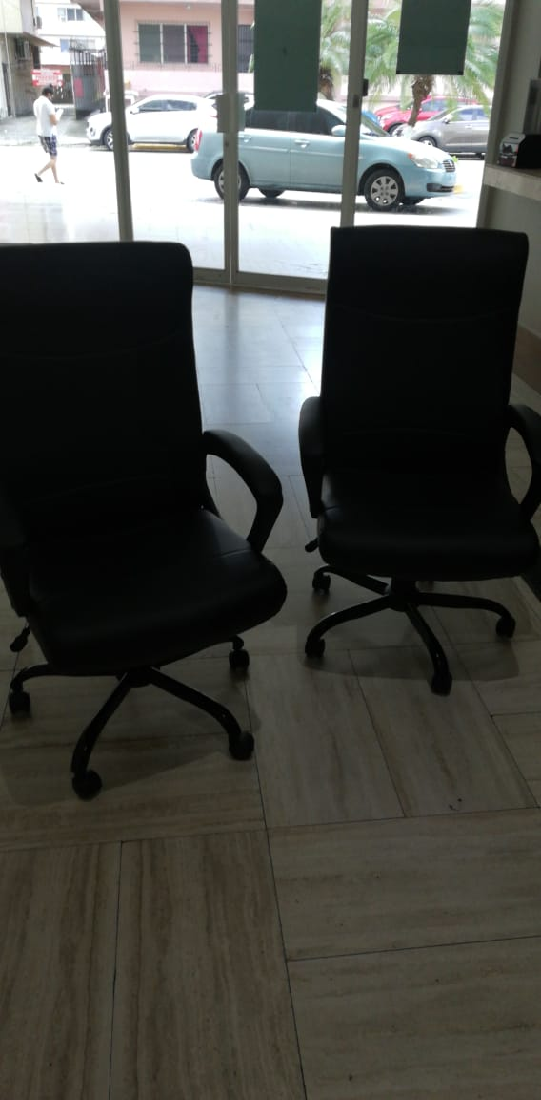
- DOTACION DE SILLA AGENTES DE SEGURIDAD TORRE 1 Y 2
- 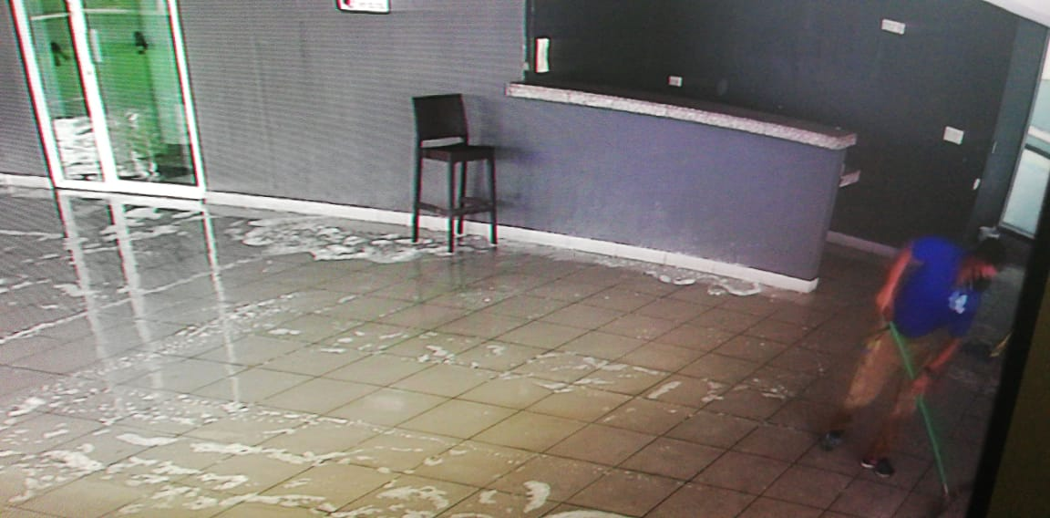
- LIMPIEZA PROFUNDAS DE LAS AREAS SOCIALES
- 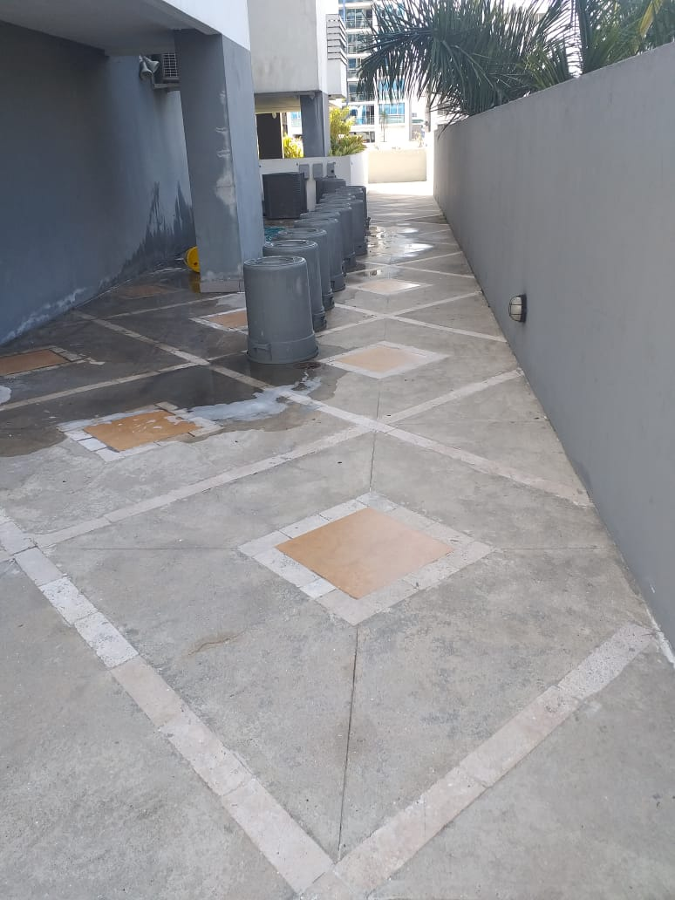
- Continúan las labores de limpieza profunda de los tinacos
- 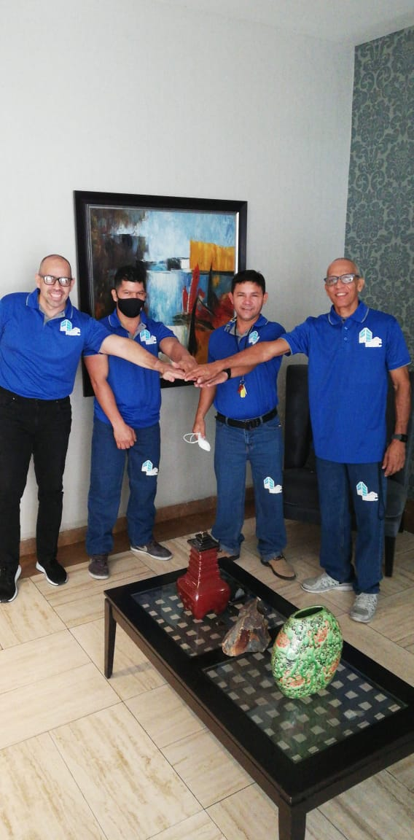

- DOTACION DE UNIFORME A COLABORADORES

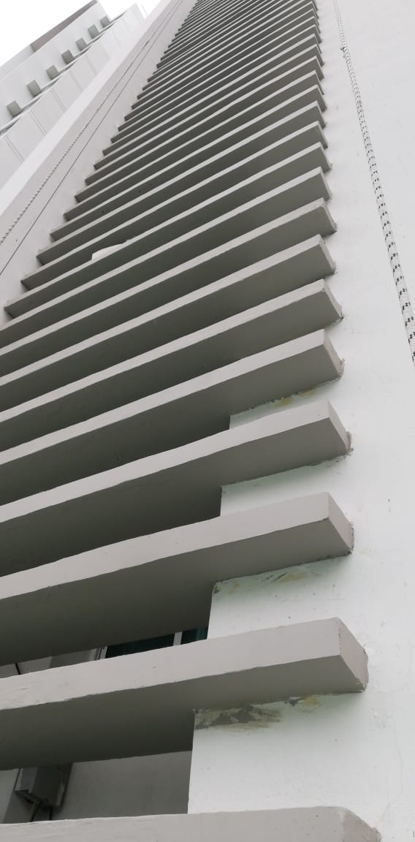
TERMINACION DE ARREGLO DE PARASOLES TORRE 2
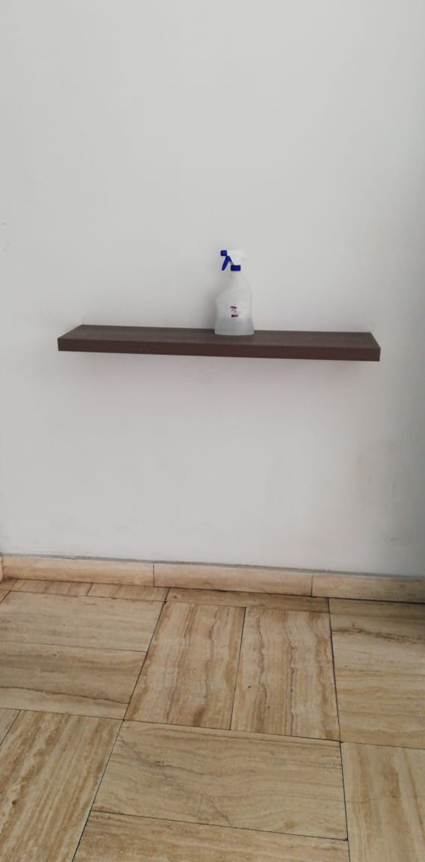
MODIFICACION DE SITIO PARA DELIVERY AMBAS TORRES

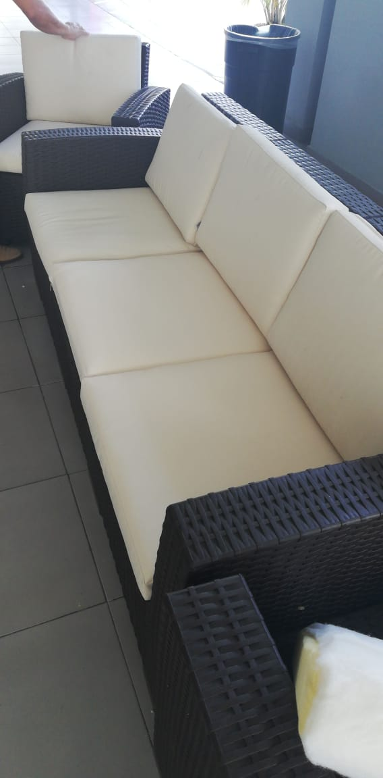
LAVADO DE COJINES MOBILIARIO AREA SOCIAL
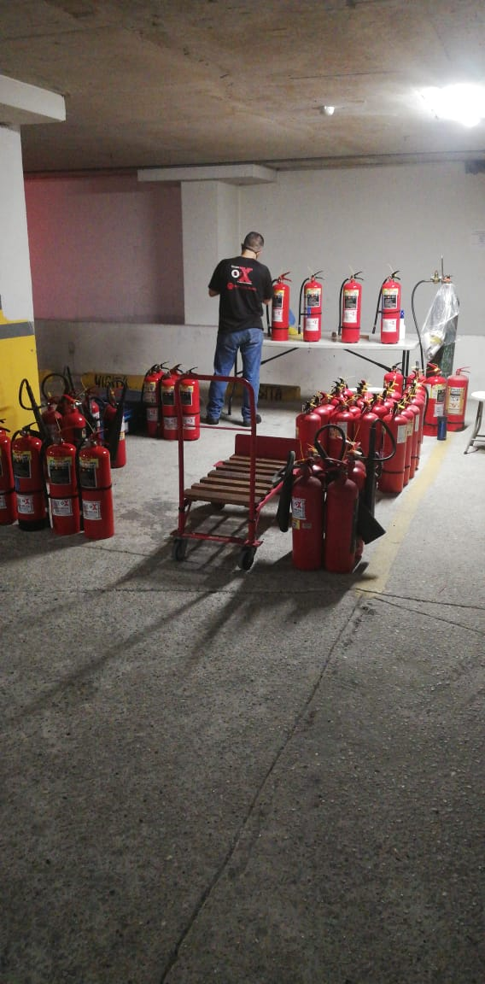
MANTENIMIENTO ANUALES DE EXTINTORES

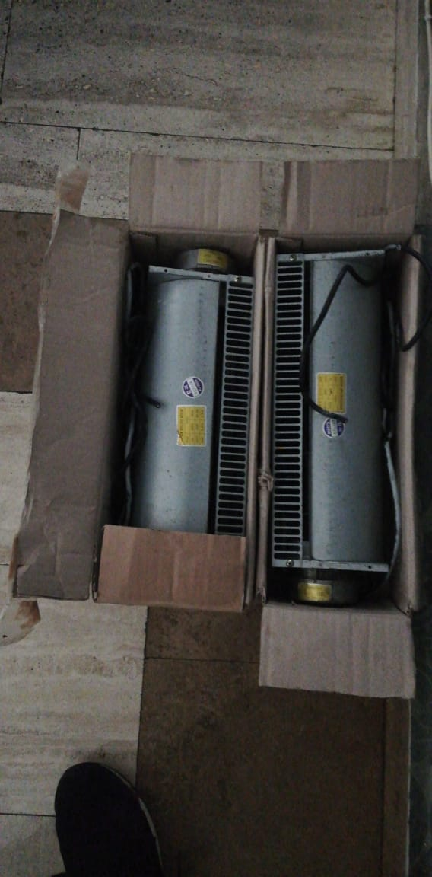Cambio de abanicos de elevadores de la torre 1

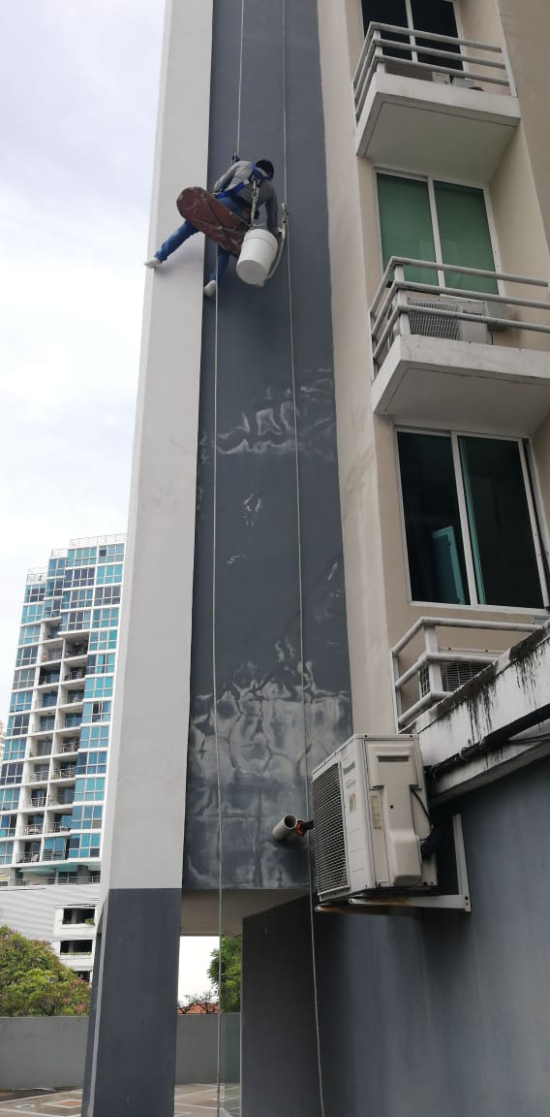
Arreglo de fachada externa de 4 apartamentos con grietas externas
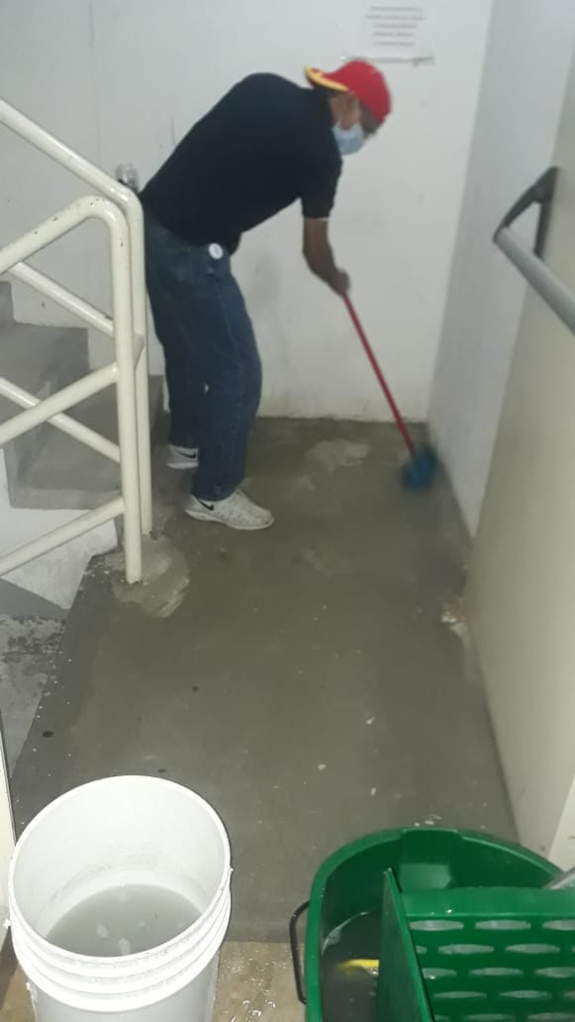
Lavado e todos los pisos donde reposan los tinacos

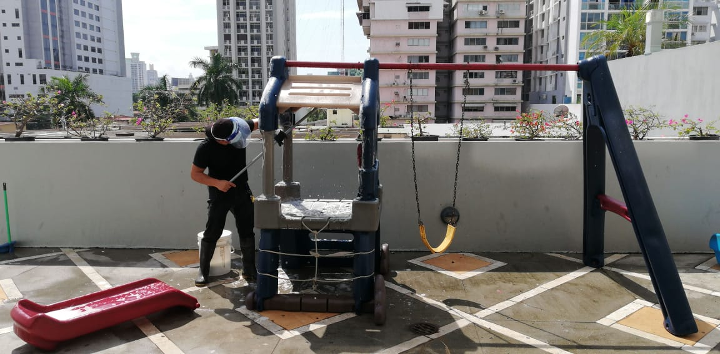
Limpieza profunda en las áreas comunes
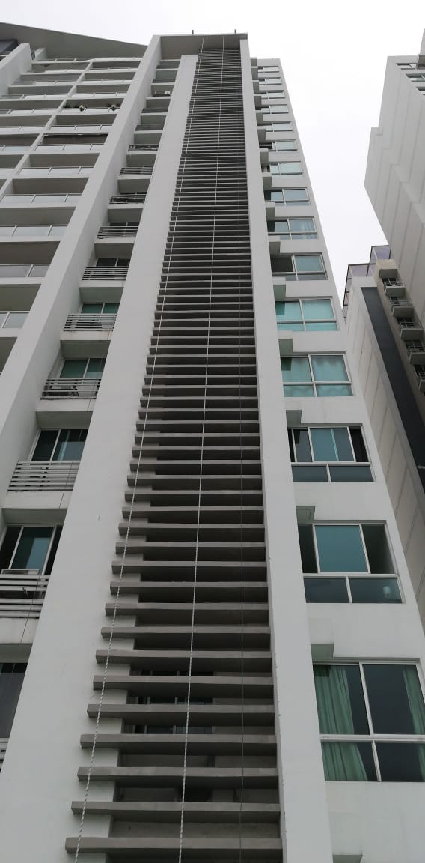C
CONCLUCION DE ARREGLO DE LOS PARASOLES EN TORRE 1

Notificación de las siguientes acciones:

- Quedaran suspendidos los cobros del 10 % por pagos de la cuota de mantenimiento posteriores a los 10 primeros días de cada mes, por el mes agosto 2020, es decir se suspende la penalidad del recargo.

- IMPORTANTE: LAS CUOTAS DE MANTENIMIENTO DEL EDIFICIO DEBERAN SER CANCELADAS DE LA MANERA HABITUAL, NO ES POSIBLE RELAJAR ESTE RUBRO, YA QUE PONDRIAMOS EN SERIOS APRIETOS CUMPLIR CON EL PAGO DE SERVICIOS BASICOS NESESARIOS COMO SON SEGURIDAD, MANTENIMIENTO DE ELEVADORES, PLANILLA,MANTENIMIENTO DE BOMBAS Y PLANTAS ELECTRICAS, PAGO DEL SERVICIO ELECTRICO ETC.
POR LO QUE INSTAMOS A TODOS LOS PROPIETARIOS QUE SIEMPRE CONSCIENTE DE LAS SITUACIONES , POR FAVOR REALICEN SUS PAGOS HABITUALES.

Todas estas medidas se toman atendiendo el precepto legal y tomando en cuenta lo mas conveniente para todos los propietarios y residentes

Se realizó el día 13 de febrero asamblea general de propietarios, escogiendo y confirmando a la junta directiva la cual fue reelecta, se aprobó también cuota extraordinaria para pintado e impermeabilizado y arreglos del edificio.

Buenos días estimados propietarios.
La presente es para informar que el pasado día 13 de febrero 2020 se celebró asamblea general de propietarios, en ella se aprobó una cuota extraordinaria la cual empezara a regir a partir del 1 de marzo del 2020, esta para los no asistentes, será para pintar el edificio, arreglar los parasoles área de piscina e impermeabilizar azotea de torre 2.
Este pago deberá hacerse en la cuenta de ahorro 0404019404661, banco general, PH KUBIC
En el cuadro que sigue a continuación determinamos los montos que debe pagar cada apartamento según su letra y en consecuencia por su tamaño, serán 12 cuotas a partir del 1 de marzo.
APARTAMENTOS | APA | COHEFICIENTE | MONTO | 12 CUOTAS
A | APA | 0.81 | 1139.66 | 94.97
B | APA | 0.81 | 1139.86 | 94.97
C | APA | 0.64 | 900.47 | 75
D | APA | 0.57 | 801.98 | 66.83
PH A | APA | 1.52 | 2138.62 | 178.21
PH B | APA | 1.24 | 1744.66 | 145.38
LOCALES COMERCIALES | APA | 0.51 | 717.56 | 59.79

POR FAVOR SEGUIR PAGANDO LAS CUOTAS DE MANTENIMIENTO
Atentamente;
La Administración.

